IQRF Summit 2018
When: April 24 - 25, 2018
Where: Clarion Congress Hotel Prague
WWW: www.iqrf.org/summit2018
After the successful IQRF Summit 2017, the next edition will be held in April 2018. Come and see the progress in the Internet of Things field, projects IQRF Alliance members are currently working on, successfully realized pilot projects and opportunities for cooperation. Again, you can look forward to a lot of real solutions and products.
Check this website to find details from IQRF Summit 2017: https://www.iqrf.org/summit2018/#media. You will find there videos of the presenting companies with a lot of interesting information.
This year you can look forward to new certified interoperable products that you can use for your long-term intents in the field of Internet things. There will also be practical workshops, the announcement of the results of the IQRF Wireless Challenge IV contest and an informal meeting of the participants.

Currently, the web of the Summit is continuously filled with information about presenting companies, speakers, and topics. Below we focus on those already registered. Do not forget to watch the Summit site for news.

Presenting companies

IQRF Tech (www.iqrf.com)
In the summer of 2017, IQRF Tech was founded, the MICRORISC’s spin-off, to take over all activities related to research, development, and sales of IQRF technology.
The solutions demonstrated at the Summit are based on this technology. It is an important representative of wireless mesh networks operating in the ISM band designed to transfer small data from a device or to control them. These are extremely low-power networks, allowing battery operation for many years. Worldwide, hundreds of thousands of devices are now installed, which are controlled by this Czech technology. The IQRF OS 4.0 operating system incorporates security mechanisms based on the AES-128 standard, including secure adding of network devices and secure data transfer.

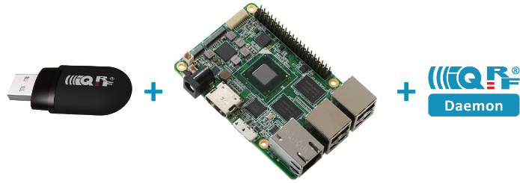
AAEON Europe (www.aaeon.com)
This company is the gateway provider in the IQRF ecosystem. From any gateway, you can easily create an IQRF Gateway by adding a USB IQRF transceiver and running an IQRF Daemon. This software was created for the IoT Starter Kit – pilot product (www.iqrf.shop) which, among other things, can be used to test your solution. The installation is simplified and well documented. You can also connect other external hardware such as sensors or active components to this kit.

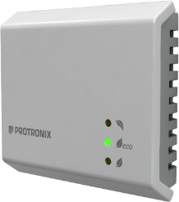
Protronix (www.protronix.cz)
One of the providers of quality sensors of internal air pollution is Protronix company. One of the first who successfully completed the certification process of interoperability of its IQRF devices, which is ensured by complying with standardized control commands. Sensors of CO₂, temperature, relative humidity or other environmental pollutants in buildings can be found at http://www.iqrf.shop where you can purchase samples.

CTI Software (www.cti.cz)
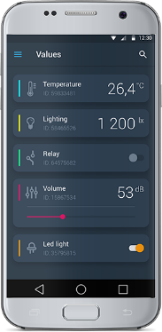
This company develops intelligent systems and services to inform users about the current state of the environment or the crisis situation based on acquired sensor data. Their phone and notification services are used today by rescuers or dispatchings who receive warnings in dangerous situations as well as owners of large plots of land (forests including) when unauthorized manipulation of property occurs. Alarms are reported to users via an automated phone call or via SMS. Phone services also include the complete operation of the call center. CTI Software also has control and monitoring software for public and industrial lighting.

Master Internet (www.master.cz)
If you need a reliable storage, you can use Master Internet Services. They offer huge datacenters, servers, and cloud solutions. Clients get a professional solution without having to take care of it all by themselves. In addition to the high-performance data center, the company offers smartphone applications with Android and iOS operating system. Among them, you can also download an IQRF mesh management application.

JoTio (www.jotio.cz)
JoTio, a young ambitious start-up, showed at a previous summit that they excellently deal with the integration of various systems used in an IoT project. If you need help with technical development or visualizing the collected data in graphs, the founders of this company can help you set up the necessary software. They use Node-RED as their favorite platform and provide training of it on demand.

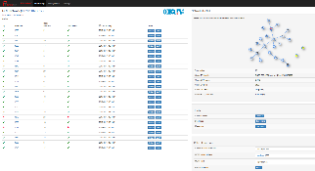
RehiveTech (www.rehivetech.com)
If you need to control your Internet IQRF gateways in remote locations, you can use the RehiveTech remote management system that responds flexibly to customer requirements and has many useful functionalities thanks to constant innovation. At the Summit, you can meet main system developers and discuss the appropriateness of deploying this software on your gateways.

Workshops
Also at this IQRF Summit, it will be possible to practice with interoperable products. To do this, a workshop will be organized, led by industry experts who either deliver end products or deal with providing and setting up the necessary services. You can try to build the entire IoT solution consisting of an IQRF network, sensors, and actuators, with data management and visualization.

IQRF Wireless Challenge IV
To enable close contact between the academic and professional community, we decided to organize the final round of the traditional developer contest here at the IQRF Summit 2018. The best projects will be presented by authors to the professional jury and the winning project will be presented on the main stage to a wide public.

Networking
We traditionally organize also a social event that allows informal meetings of all participants. People there can discuss common topics and share ideas. Experience shows how beneficial this type of event is, and how it helps in establishing new business partnerships.

Organizer

IQRF Alliance
Průmyslová 1275
Valdické Předměstí
506 01 Jičín
+420 777 571 699
alliance@iqrf.org
www.iqrfalliance.org
Contact
Ivona Spurná
Event manager & PR
ivona.spurna@iqrf.org
+420 777 775 735

